7 April 2015
Draft Proposal of the .mu Select Committee for the new .mu ccTLD Framework

Problem statement
- .mu (dot mu) is the country code top level domain for Mauritius. It is a national identifier similar to the +230 country code which is used to identify Mauritius for telephone calls. It is presumed that the .mu ccTLD was delegated in 1995 by the Internet Assigned Numbers Authority (IANA) using the notion that a “responsible person” in the country would act as a trustee for the ccTLD and and have a duty to serve the community. The .mu ccTLD is currently being administered and technically managed by a private company known as Internet Direct Ltd.

- The current state of affairs is as follows:-

    - On the one hand, the current .mu ccTLD policy, technical and commercial functions are run by the same private entity; and,

    - On the other hand, sections 12 & 13 of the ICT Act 2001, as amended, provide for the Internet Management Committee whose members are appointed by the Minister to administer and manage the .mu ccTLD instead of it instead of being selected on an elective, and in a fair and transparent manner.

- Both 2(i) and 2(ii) above are in breach of ccTLD international practices as those two ccTLD frameworks do not allow the local Internet Community (Mauritius) to have any say on the policy, technical and commercial functions of the dot mu ccTLD. In addition, 2(i) is a private monopoly which is not accountable to anyone.

A Way Forward
- A way forward is to have a .mu ccTLD framework with a three-tier model, consisting of:
(i) Policymaking for dot mu,
(ii) Technical management of the dot mu ccTLD servers, and
(iii) Commercial operation
where each tier shall be under the responsibility of separate entities.

A ccTLD is a virtual monopoly; clear delimitation and segregation of duties and responsibilities is required to avoid having a .mu ccTLD framework where an entity could engage in conduct that constitutes exploitation of the monopoly situation.
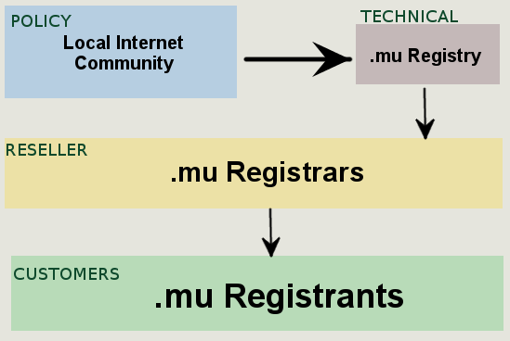

- The proposed three-tier model should lead to affordable pricing for .mu domain names if the entity responsible for the technical management of dot mu (.mu Registry) is run on a not-for-profit basis and in a fair and transparent manner.

Multistakeholder committee
- The Ministry of Technology, Communication and Innovation has set up a multistakeholder committee with a view to formalizing a structure which will implement the new .mu framework. It is recommended to set up a not-for-profit entity to implement the new .mu ccTLD framework, in line with international practices and with full transparency and accountability towards the local Internet community (Mauritius), and the rest of the Internet community. The not-for-profit entity will then make the request for a re-delegation of the .mu ccTLD.

With the proposed new framework, the .mu ccTLD will seek to provide Mauritian people with a digital identity that is managed by an entity, which is open to the local Internet community. The overall objective is that the .mu country code top level domain should be the obvious choice for all Internet users residing in Mauritius.

- Proposed Action Plan
In a nutshell, three main action lines are proposed
  - Set up a not-for-profit entity to implement the new .mu ccTLD framework
  - Necessary amendments to the ICT Act 2001
  - The not-for-profit entity to implement the technical infrastructure (registry) required prior to filing the case for delegation
It is recommended that 2 is implemented by the Ministry of Technology, Communication and Innovation.

Action line 1
As described in section 6 above, the starting premise is to set up a not-for-profit entity as a legal entity.
- The Ministry of Technology, Communication and Innovation is to ensure that the present initiative is transformed in a proper legal entity. It is recommended that the legal entity takes the form of a not-for-profit entity which is based on the following:
  - Neutral status
    - fair treatment to everyone in Mauritius.
    - Does not confer special status to the government or any group.
  - Non-profit
    - Not profit-driven, but service-driven.
    - out to promote competition amongst the .mu registrars.
    - Works for the benefit of the local Internet community.
  - Member driven.
    - Promotes transparency in Registry Operations.
    - Ensures accountability.

- The not-for-profit entity will have to engage in consultations with the local Internet community in a comprehensive manner and ensure that there is consensus for the new .mu ccTLD framework.

Action line 2
  - The current Internet Management Committee model (as per the ICT Act 2001) where the appointment of members is made by the Minister is to be changed. The Ministry of Technology, Communication and Innovation has already proposed to completely remove the the administration and management of .mu domain names from the ICT Act.

Action line 3
- The new .mu ccTLD framework will have to be operational before the request for redelegation is made. It is recommended that the technical set-up be fully operational within six months given that .mu is a single point of failure. A technical proposal together with a cost breakdown is included in Annex 1 to provide a view of whether the technical implementation is feasible.

Technical Implementation issues to be considered
- Initial cost of implementation
- Registry location (sensitive issue)
- Sustainability of the operations (Business model)
- Time frames for implementations
- Registry application systems.

Overcoming the Technical Implementation challenges
- Registry location is sensitive – should be neutral where possible decided or agreed upon through a consensus process.
- Registry should be self sustaining.
- Generate revenue through domain registrations.
- Keep the operational costs of the registry to the minimum.
- Automation of Registry to provide efficient service.
- Do not re-invent the wheel, it takes time and resources.

